**How to Run Instructions: PC Audit Tool**

Table of Contents

Table of Contents 1

1. Document Revision History 2

2. Important Notes before starting 3

3. Running the application 3

4. Running the application Option – 2 4

## Document Revision History

| **Version** | **Date** | **Author** | **Comments** |
| --- | --- | --- | --- |
| 1.0 | 7/25/2025 | Matthew Guarino | Rough Draft |
| 1.1 | 8/1/2025 | Matthew Guarino | Title page, table of contents, document revision history, added detailed instructions |
|  |  |  |  |

**!!!!Important NOTE!!!!**

* Prior knowledge of command line prompts would help with how to run the application
* It is very important to know the location of your PY files in your directory
  + For example, below is where I put my project
    - C:\Users\aegua\PycharmProjects\ENHANCED_pc_audit_tool

**How to Run the Application**

**Option 1 – Command prompt**

1. Find the command prompt and open it as administrator
2. Navigate to the folder where the project is
   1. Use the cd command
      1. cd C:\Users\aegua\PycharmProjects\ENHANCED_pc_audit_tool
3. Sanity Check (to make sure you already have Python installed)
   1. Python --version
      1. You should see Python 3.xx.x (whatever version you have installed)
4. C:\Users\aegua\PycharmProjects\ENHANCED_pc_audit_tool> py pc_audit_gui.py
   1. Result: Imports successful
   2. Application opens up

**Option 2 – IDE (Pycharm)**

**NOTE:** This requires you to download PyCharm Community Edition. This is a free IDE downloadable from the internet. More information can be found here below

* <https://www.jetbrains.com/pycharm/>

1. Click on PyCharm Community Edition x.xx.xxx
   1. With Projects highlighted on the left side it should show you what projects are available to open.

NOTE: Use a naming system that doesn’t confuse you which project to open/work on

1. Click on “pc_audit_gui.py”

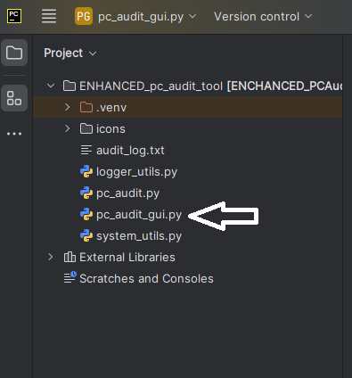

1. At the top of the application you will see a play sign and a stop sign
   1. Click on the play sign and the application will open
   2. You can also run the application by clicking on the menu symbol

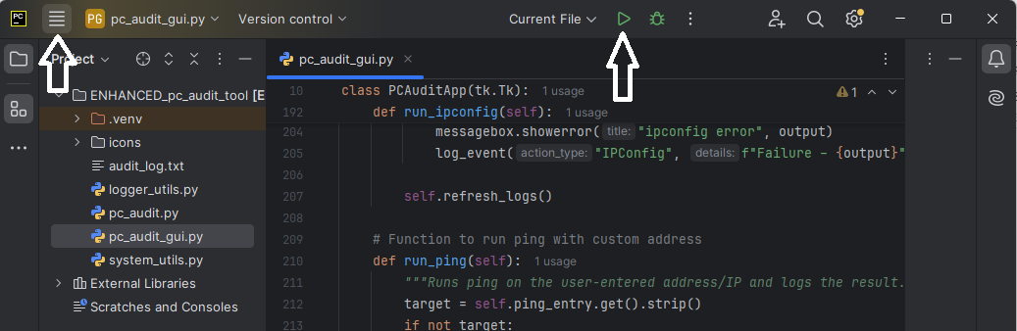

* 1. Go to RUN 🡪 RUN ‘pc_audit_gui.py’

1. **SUCCESS**

NOTE: Noticed the terminal below that reads: “Imports successful” (just like in the command prompt) This is exactly what you want to see.